Jack Johnson

August 24, 2021

Section End Project: Log Records with node.js

Link to my GitHub repository: <https://github.com/jjohn98/2058519_Jack_Johnson_Mean_Stack>

This project is located in ~/Phase3/Log Records.

In this project, I created 2 files. The first file is log_record.js which houses all of the code written to run the program. The second file is logs.json, which is just the file that the program reads and writes to.

In log_record.js, I wrote a simple program which takes user input, then creates a json object using the input information. This object is then used to either create a new json object array in the logs.json file, or appended to this array if the array already exists. There are also many debugger; commands which can be used with the node –inspect command to debug the application. The program does run fine even when using node –inspect, so there are no errors.

The files for this project will be in the GitHub repository, as well as the source code section of the submission on Simplilearn.

Screenshots of outputs and output files:

User Input:

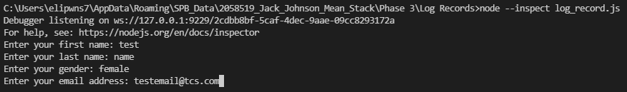

Console output:

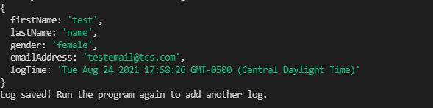

Json file output:

